Math 4 Name_______________________________

**3-3 Properties of Rational Functions** Date________

*Learning goal:*

*I can identify important characteristics (asymptotes, holes, intercepts, and end behavior) of*

*rational functions.*

From your previous work in mathematics, answer the following question:

1. If you are given a function, how do you find the following:

a. *x*-intercepts -

b. *y*-intercept -

c. asymptotes - Vertical:

Horizontal:

Oblique:

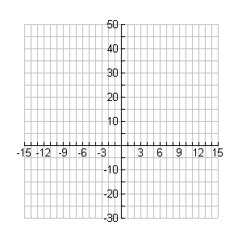2. Use the information above to algebraically find the *x*-intercepts, *y*-intercepts, and asymptotes of the rational functions below. If there aren’t any, write “none.” Then graph the functions on your calculator to verify that you are correct. Sketch a graph on the provided axes.

a. 

*x*-intercepts:______________________

*y*-intercept: ____________

Vert. asymptotes:

Horiz asymptotes:

Oblique asymptote:

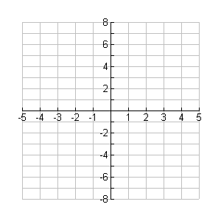b. 

*x*-intercepts:______________________

*y*-intercept: ____________

Vert. asymptotes:

Horiz asymptotes:

Oblique asymptote:

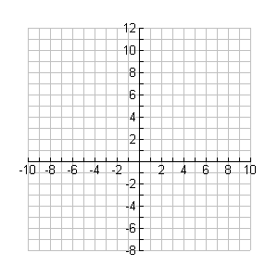

c. 

*x*-intercepts:______________________

*y*-intercept: ____________

Vert. asymptotes:

Horiz asymptotes:

Oblique asymptote:

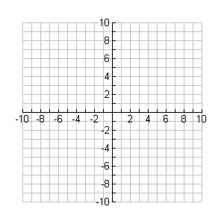

d. 

*x*-intercepts: _______________________

*y*-intercept: ______________

Vert. asymptotes:

Horiz asymptotes:

Oblique asymptote:

2. Based on your work above, fill in the table below:

**Rational functions:** 

***Asymptotes***

|  |  |  |
| --- | --- | --- |
|  | ***How do I know there is one?*** | ***How do I find the equation?*** |
| **Vertical** |  |  |
| **Horizontal** |  |  |
| **Oblique** |  |  |

3. Explain when a graph will have a hole (also called a **removable discontinuity**) instead of a vertical asymptote (also called an **essential discontinuity**).

4. Find the information for the following rational functions. Use your calculator to help, if necessary.

a. 

*x*-intercept(s): _________________ *y*-intercept: ___________

vert. asymptotes:________________ horiz. asymptotes: ______________

oblique asymptote: _____________ Domain: ________________

Hole: __________

b. 

*x*-intercept(s): _________________ *y*-intercept: ___________

vert. asymptotes:________________ horiz. asymptotes: ______________

oblique asymptote: _____________ Domain: ________________

Hole: ________

c. 

*x*-intercept(s): _________________ *y*-intercept: ___________

vert. asymptotes:________________ horiz. asymptotes: ______________

oblique asymptote: _____________ Domain: ________________

Hole: ______

d.

*x*-intercept(s): _________________ *y*-intercept: ___________

vert. asymptotes:________________ horiz. asymptotes: ______________

oblique asymptote: _____________ Domain: ________________

Hole: ______